$$a,b,c,d>0$$

Case 1:

$$x>\frac{d+b}{a+b+c+d}$$

$$y<\frac{\left(d+c\right)x-d}{\left(a+b+c+d\right)x-\left(d+b\right)}$$

Case 2:

$$x<\frac{d+b}{a+b+c+d}$$

$$y>\frac{\left(d+c\right)x-d}{\left(a+b+c+d\right)x-\left(d+b\right)}$$

Example

$$a=3,b=c=2,d=1$$

Case 1:

$$x>\frac{3}{8}$$

$$y<\frac{3x-1}{8x-3}$$

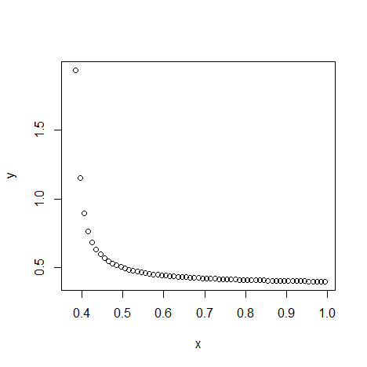

$$x=1$$

$$y<\frac{2}{5}$$

Case 2:

$$x<\frac{3}{8}$$

$$y>\frac{3x-1}{8x-3}$$

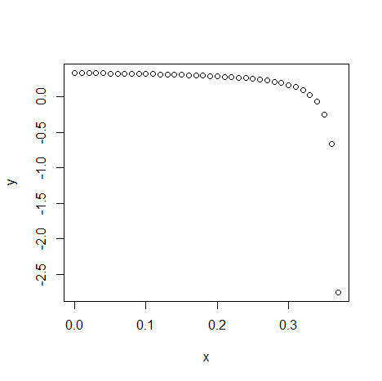

$$x=0$$

$$y>\frac{1}{3}$$

Conclusion

$$y∈\left[\frac{1}{3},\frac{2}{5}\right]$$